L5M4 Worked Example Task 1
Question
Describe five methods that can be used to carry out supplier development on a key external supplier (25 marks)

Approach to answering the question
- Always, always, always create a plan in the first instance.
- Reasons for this include
  - Creates a very good first impression to the assessor, high chance that he/ she will read the plan carefully and just skim over the essay, checking to see if the points have been included in the essay (the assessor could have hundreds of essays to mark)
  - Having a structure to your essay
  - Avoids repetition of key areas
  - Avoid omission of key areas
  - Allocates approximate marks to each section and gauges volume
  - Gains some marks if you run out of time in writing the essay
It is important to create your plan in the main body of Testreach, rather than the notes section as this information isn’t shared with the CIPS assessor.
Remember – QUALITY over QUANTITY of content
Note
It is very easy to jump straight into writing the essay, don’t do this for the reasons mentioned above. Students may feel that they need to do this and get some comfort by getting stuck in straight away, recognise this and hold back by creating the plan.
For each L5M4 question there is 45 minutes to complete. Don’t allocate time to review your answers as CIPS suggest but put this time into your plan.
For each 45-minute question spend around 15-20 minutes writing your plan out. It seems a lot but after your plan all your answers will be there and students merely have to write them out.

Remember – QUALITY over QUANTITY of content

Step 1 Plan Creation
- Write the top level answer to the question straight away. The Testreach system will allow students to write in-between the answers for the next stage. This is probably the most important stage of the whole answer development. Get the majority of this bit wrong and your will fail the question, hence the reason to take time planning our your answer.

Question asks students to ‘Describe five methods that can be used to carry out supplier development on a key external supplier’.
Look for the clues in the question, ‘development’ relate to LO 1.3, it is important in your revision to understand the structure of the module itself.
So, this is your ‘go to ‘area of the module.
From experience, if there is no indication in the question of how many segments are required (in this case it does state ‘Describe five methods’, assume for a 25-mark question there will be five. We’re looking for five segments, each containing five marks each.
For a 20-mark question it will be only four segments required. For a 16-mark question there will also be four segments, but less in content than a 5 x 5 mark question.

From this LO five methods can be (there are more so pick your strongest)
- Knowledge and technology transfer
- Continuous improvement reviews and strategies
- Supplier capability assessments
- Supplier relationship management
- Identifying opportunities to use technology

It is very important to recognise that each of your top line ‘segments’ will gain considerable marks in relation to overall mark allocation. From student feedback this can be anywhere in the range of at least one mark to a possible two marks (total 5-10 marks), so it is very important you get this first step right.
Remember that you only need 12.5 marks to get a pass, but obviously go for 100%.

Step 2 Plan expansion
This is the step where students need to be creative. It is extremely important for students to understand that the CIPS assessor does not have an exclusive list that shows what is ‘right’ or ‘wrong’, as long as your answer ties into the segment description, which in turn ties into the answer you will get marks.
Use this as an opportunity to be creative.
It is important at this point to understand the CIPS keywords, which are below.
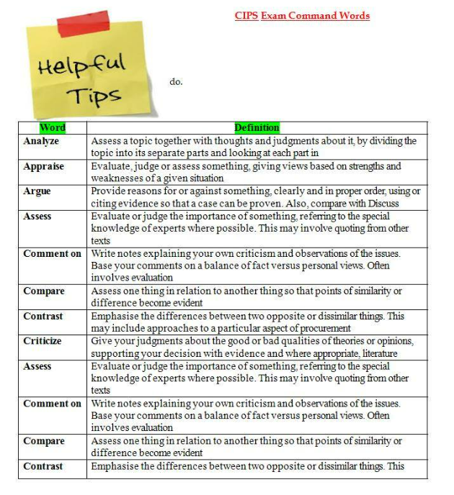
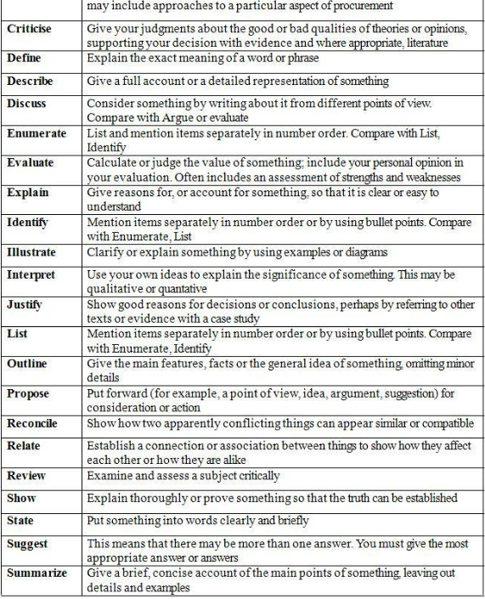

This may seem like an awful lot (ignore the duplications), but from experience and student feedback the most popular ones are below:
- Compare
- Describe
- Evaluate
- Explain
- Identify (to a lesser extent)
- Outline (to a lesser extent)

From the above shortlist these can be trimmed down even further:
- Compare/ Evaluate
- Describe/ Explain
- Identify/ Outline

With the first set students will be expected to focus on advantages and disadvantages of the subject matter. The second set will require students to explode out their points using the technique below and the third set always offers less marks, especially at AD level, where the identification of the subject matter is required. Essentially, the identification element has already been carried out in Step 1.
So, we know that the keyword in this question is 'describe’, which falls into the first set, and the segments identified earlier needs to be expanded on. This is where the technique WHO, WHAT, WHY, WHERE, WHEN, HOW and WHAT IF should be used, asking these questions on the question itself. In addition, certain tools such as SWOT, Kraljic etc could also be used.
As mentioned, this is a 25-mark question so we’re looking for five marks in each of the five segments. To gain these five marks we’ve estimated that you need three ‘legs’, or sub-segments’, under each segment. Using the technique mentioned earlier the below plan can be finalised by inserting text in-between the segment headers in the Testreach system.
The capitals are for guidance only and should not be incorporated into your own plan in the exam. Try and keep them short, should only be used as a trigger when writing your essay.
- Knowledge and technology transfer – 1 to 2 marks
  - WHAT – Product/ process/ quality/ - 1 to 2 marks
  - WHY – Increase suppliers performance/ risk reduction 1 to 2 marks
  - HOW -ESI/ consultation/ training/ education/ transfer of personnel
- Collaborative product/ service development
  - WHAT – NPD/ ESI
  - WHY – Competitive advantage/ first to market/ patents/
  - HOW – Development concept/ prelim design/ evaluation/ prototype/ final design
- Continuous improvement reviews and strategies
  - WHAT – Products/ services/ process/ systems/ relationships
  - WHY – Want to get better/ proactivity/ decreased costs/ increased quality etc
  - HOW – PDCA/ / TQM/ philosophies
- Supplier capability assessments
  - WHAT – Quality systems/ financial capability/ IT/ personnel/ existing performance
  - WHY – Increase performance/ sharing knowledge/ issue identifier
  - HOW – Supplier selection criteria (Carter’s 10 c’s)/ KPI’s/ ongoing monitoring/ tech road maps
- Identify opportunities to use technology
  - WHAT – Blockchain/ AI/ 3D printing
  - WHY – ESI/ joint collaborations/ automation/ performance improvement
  - HOW – Collaboration with stakeholders/ suppliers/ info sharing/ planning/ shared goals

To begin with the plan creation will be quite slow, there are two reasons for this:
- Your knowledge will likely not be up to exam standard just yet (plan practice is a good revision tool also)
- Getting used to the technique
With practice it does get quicker. Should be aiming for 20-minute max on the plan creation to the second level.

Step 3 Essay writing
As mentioned earlier, by this stage the hard work has been done. Now students simply need to insert the information into essay format.
Structure is still important in this area. Create separate paragraphs for each segment header to keep them separate and distinct, this will also help you to keep on track and mentally tick each one off as you go along. It’s important to consider your plan isn’t fixed as when students ‘get into’ the question additional thoughts may come in, if they are relevant put them in but watch your time.
Click on ‘review’ in the toolbar to see comments in the essay for guidance. The essay has covered the first segment header.

Essay
Supplier can be used for both attempting resolve problems with a supplier or to capture opportunities. Supplier development does cost money and can be quite resource intensive, so this is best used for critical suppliers, notable those in the bottleneck quadrant and especially those in the strategic quadrant of the Kraljic matrix. There are several methods that the procuring organisation can use to development suppliers; knowledge and technology transfer, new product development, conducting continuous improvement reviews and strategies, carrying out supplier capability assessments and using technology to identify opportunities.
Knowledge and technology transfer is the first method, and this consists of information sharing between the procuring organisation and the supplier. This can focus on several areas of each organisation such as production, processes and quality. Certain tools can be used in this area which include lean manufacturing for production and six sigma for quality. Even though knowledge and technology transfer often involved transferring skills, resources and information from the procuring organisation to the supplier there could well be some reciprocal transfer from the supplier to the procuring organisation.
The main reason organisations transfer such value to a supplier is so suppliers performance increases, or at least comes up the level that is satisfactory to the procuring organisation. There may be situations where a supplier is providing defecting products to the procuring organisation and are weak in best practice quality techniques. The procuring organisation can offer their quality manager to assist in creating a framework using statistical process control (SPC) to help resolve the issue.
This is carried out initially by identifying areas of weakness or opportunities. It may be that there has been a negative event, in which case further investigate is needed to identify the root cause, using tools such as Failure Modes and Effects Analysis (FEMA). For any transfer to be effective there does need to be a high level of trust and collaboration between the parties involved. There could be the potential that the supplier may use the newfound information or skills to their advantage with other customers, which could be the procuring organisation that is transferring the skills own competitors.

L5M4 Worked Example 2 (plan only)
Question
Describe five methods that can be used to measure and improve supply chain performance (25 marks)
Plan to 2nd Step
- Supplier rating – 1 to 2 marks
  - WHAT – Systematic approach/ supplier performance/ - 1 to 2 marks
  - WHY – Communication performance/ risk avoidance/ reduction 1 to 2 marks
  - HOW -KPI’s/ weighting/ scoring/ forms 1 to 2 marks
- Innovation capability
  - WHAT – New product development/ processes/
  - WHY – Competitive advantage/ improved performance/ reduced costs
  - WHO – Cross functional teams/ suppliers & buyers/ roles
- E-system integration
  - WHAT – Connecting electronic systems/ buyer/ supplier/ customer?/ data sharing
  - WHY – Collaborative/ quick decision making/ visibility/ business objectives
  - HOW – Identify partners/ develop strategies/ put measures in place/ ongoing monitoring (PDCA)
- Supplier relationship management
  - WHAT – Not all relationship the same/ SCM approach/
  - WHY – relationships link to performance/ supply chain competing/
  - HOW – Identify critical spends/ create performance framework/ shared goals/ communication strategy
- Balancing qualitative and quantitative measure of performance
  - WHAT – Quantitative data desc/ qualitative data desc
  - WHY – Attempts to avoid limitations of one type of data/ complementary
  - HOW – Embed in design/ use of balanced scorecards

